Gamemaker Code – programming with code
Tony Forster August 2006

May be copied or modified with acknowledgement of authorship

Rather than drag and drop actions, you can use code. Code allows you to do a lot of things that are not possible with just drag and drop.

In this tutorial, we will make a game using all code, even though we could have used drag and drop.

The “execute a piece of code” action looks like this:

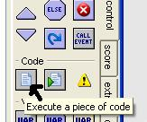

You can type code into this window or paste to it from help or elsewhere. Note how the color changes when Game Maker recognises something, for example:

light blue for variables
dark blue for functions
red for constants
magenta for objects
green for comments
bold for language words

If you don’t get the colour you expect, you have made a typing error

Getting started
Just like any other Game Maker game, you will need a sprite
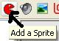

I’ll choose the teddy


You will need an object
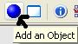

You need to assign the sprite to the object
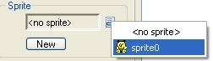

You need a room
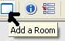

You need to put the teddy in the room
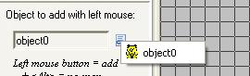

Making Teddy Move
OK so far its all been the same as what we’ve done with drag and drop. Now we’ll make teddy move with the arrow keys but we’ll use code.

Add event keyboard left
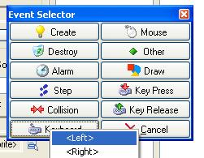

Drag an “Execute a piece of code” action into the action window

See how a window opens up
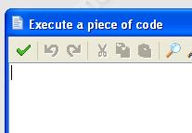

When we hit keyboard left we want teddy to move left, we want to set the horizontal speed to a negative value because in Game Maker, positive is too the right. There’s an inbuilt variable for every object, the horizontal component of speed hspeed.

How did I know that? Its in the help.
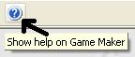

All the code stuff is at the end under Game Maker Language (GML)
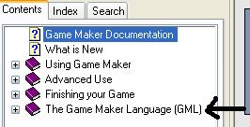

I found about hspeed in Gameplay – Moving around
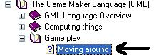

hspeed Horizontal component of the speed

Lets make hspeed –5
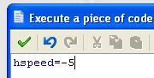

Note how hspeed is in blue, Game Maker recognized it as a variable

Just like hspeed is the horizontal component of speed, vspeed is the vertical component.
Now add event keyboard right, make hspeed =5
add event keyboard up make vspeed =–5
add event keyboard down make vspeed =5

See how we can move teddy with the cursor keys. Now I want teddy to stop when I’m not pressing a key.
Add event keyboard no key
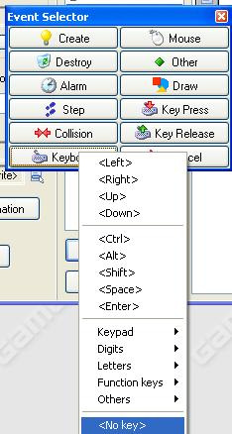

And drag in the “execute a piece of code” action

Now I could type
vspeed=0
hspeed=0

but I read the help and noticed another variable speed so I’ll just type
speed=0

Ok it works. What next?

Something to shoot at
Shooting is not ‘politically correct’. Big problem. Ghosts don’t have rights. Lets shoot ghosts.

Like before get a new sprite


Get a new object, assign the sprite to the object and put the object in the room
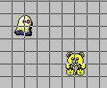

Ok, we want the ghost to move in a random direction
Add a create event for the ghost
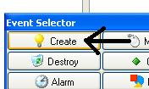

Drag an “Execute a piece of code” action into the action window
We’ll give the ghost a fixed speed but a random direction
speed=5
direction=random(360)

How did I know about the variables speed and direction?
Found them same place as vspeed and hspeed

How did I know about the function random

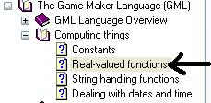

random(x) Returns a random real number between 0 and x. The number is always smaller than x

Lets keep the ghost in the room by making it wrap
Add event other / outside room
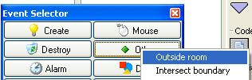

Add this code to make it wrap
move_wrap(true,true,0)

Where did move_wrap(true,true,0) come from?

move_wrap(hor,vert,margin) Wraps the instance when it has left the room to the other side. hor indicates whether to wrap horizontally and vert indicates whether to wrap vertically. margin indicates how far the origin of the instance must be outside the room before the wrap happens. So it is a margin around the room. You typically use this function in the Outside event.

Note how true is red, it is a pre-defined constant

OK Lets Shoot!!

We need a sprite for our bullet, an object for our bullet and we need to assign the sprite to the object. Do it. The bullet should be object2

Now, we’ll shoot bullets from the teddy when we press space
For object TEDDY add event keyboard space
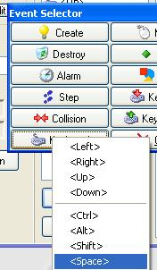

And add the following code
instance_create(x,y,object2)

(I’m assuming that object2 is your bullet too)
Because we are inside the teddy object, x and y refer to the position of the teddy so the bullet appears where the teddy is, position x,y

Where did instance_create(x,y,object2) come from?

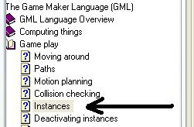

instance_create(x,y,obj) Creates an instance of obj at position (x,y). The function returns the id of the new instance

Small problem, the bullet doesn’t move
For the bullet, add event create

speed=10
direction=object0.direction

The bullets are created with speed=10 and their direction is set to the same direction as the teddy

What’s the dot all about?
In direction=object0.direction the dot “.” is important
If we are inside an object, x, y , vspeed, hspeed etc refer to that object, if we want to refer to other objects we use the dot

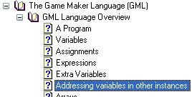

Kill Ghosts
Ok when the bullet collides with the ghost we destroy the ghost. Easy.

For object ghost add the collision event with the bullet
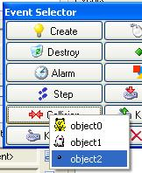

And add the following code
instance_destroy()

Where did instance_destroy() come from?

In case its not working for you, here’s the pseudo code for my program. You can display pseudo code with alt / edit / show object information
My teddy is object0, ghost object1 and bullet object2

Information about object: object0

Sprite: sprite0
Solid: false
Visible: true
Depth: 0
Persistent: false
Parent: <no parent>
Mask: <same as sprite>

Keyboard Event for <no key> Key:
execute code:

speed=0

Keyboard Event for <Space> Key:
execute code:

instance_create(x,y,object2)

Keyboard Event for <Left> Key:
execute code:

hspeed=-5

Keyboard Event for <Up> Key:
execute code:

vspeed=-5

Keyboard Event for <Right> Key:
execute code:

hspeed=5

Keyboard Event for <Down> Key:
execute code:

vspeed=5
______________________________________________________

Information about object: object1

Sprite: sprite1
Solid: false
Visible: true
Depth: 0
Persistent: false
Parent: <no parent>
Mask: <same as sprite>

Create Event:
execute code:

speed=5
direction=random(360)

Collision Event with object object2:
execute code:

instance_destroy()

Other Event: Outside Room:
execute code:

move_wrap(true,true,0)

______________________________________________________

Information about object: object2

Sprite: sprite2
Solid: false
Visible: true
Depth: 0
Persistent: false
Parent: <no parent>
Mask: <same as sprite>

Create Event:
execute code:

speed=10
direction=object0.direction

______________________________________________________

Total for the above, 10 marks

Add a sound when you shoot 1 mark
Hint:
You’ll find sound_play(sound0) at
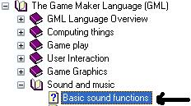

When you shoot all ghosts, go to the next room 1 mark
Hint:
Use if , instance_number() and room_goto_next()

Make homing missiles 1 mark
Hint:
move_towards_point()

Show the score 1 mark

Show a dialogue box congratulating you when you have won the game
1 mark

Show the help screen when you first start the game 1 mark

When you shoot the ghost boss, have 10 ghosts spawn at random places which you then have to shoot 1 mark
Hint:
Use random()and instance_create()

In the above, instead of using repeat () use for()
1 mark

In the above, instead of using repeat () use do
1 mark

In the above, instead of using repeat () use while()
1 mark

